Bilingual Dictionary

What is Bilingual Dictionary
# Source: AI Source: Provided by: [Data Path: Persons Table -> ID Column: 1, Name_En Column: Motasem Essam] -> From: [Chatgpt (GPT-4-turbo)] on [7/29/2025]
A Bilingual Dictionary provides word meanings in two different languages, translating entries from one language (the source language) into another (the target language). It is primarily used to support language learning, translation, and cross-linguistic understanding.

🔹 Key Features of a Bilingual Dictionary
# Source: AI Source: Provided by: [Data Path: Persons Table -> ID Column: 1, Name_En Column: Motasem Essam] -> From: [Chatgpt (GPT-4-turbo)] on [7/29/2025]
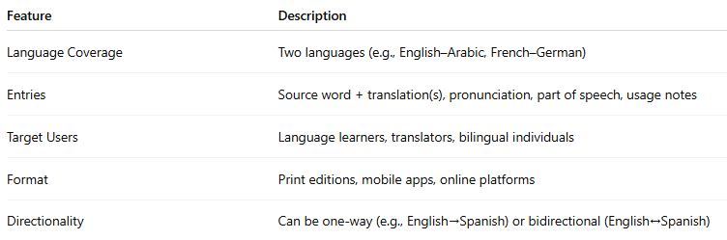
Feature | Description
Language Coverage | Two languages (e.g., English–Arabic, French–German)
Entries | Source word + translation(s), pronunciation, part of speech, usage notes
Target Users | Language learners, translators, bilingual individuals
Format | Print editions, mobile apps, online platforms
Directionality | Can be one-way (e.g., English→Spanish) or bidirectional (English↔Spanish)

🔹 Examples of Bilingual Dictionaries
# Source: AI Source: Provided by: [Data Path: Persons Table -> ID Column: 1, Name_En Column: Motasem Essam] -> From: [Chatgpt (GPT-4-turbo)] on [7/29/2025]
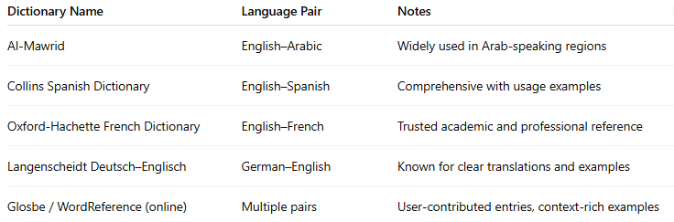
Dictionary Name | Language Pair | Notes
Al-Mawrid | English–Arabic | Widely used in Arab-speaking regions
Collins Spanish Dictionary | English–Spanish | Comprehensive with usage examples
Oxford-Hachette French Dictionary | English–French | Trusted academic and professional reference
Langenscheidt Deutsch–Englisch | German–English | Known for clear translations and examples
Glosbe / WordReference (online) | Multiple pairs | User-contributed entries, context-rich examples

🔹 Advantages
# Source: AI Source: Provided by: [Data Path: Persons Table -> ID Column: 1, Name_En Column: Motasem Essam] -> From: [Chatgpt (GPT-4-turbo)] on [7/29/2025]
- Facilitates translation and comprehension across languages
- Useful for early-stage learners before transitioning to monolingual resources
- Helps build active and passive vocabulary
- Aids interpreters, language workers, and travelers

🔹 Use Cases
# Source: AI Source: Provided by: [Data Path: Persons Table -> ID Column: 1, Name_En Column: Motasem Essam] -> From: [Chatgpt (GPT-4-turbo)] on [7/29/2025]
- Language education (schools, universities, self-study)
- Translation and interpreting
- Travel and communication
- Cross-linguistic research

